About:
Tired of circling for elusive parking spots? Our smart system utilizes AI to instantly match drivers with vacant spaces, saving everyone time and reducing traffic congestion. Parking owners rejoice! Say hello to optimized space utilization, increased revenue, and valuable data insights – all while promoting a greener city with less cruising. It's a win-win for drivers, owners, and the environment.




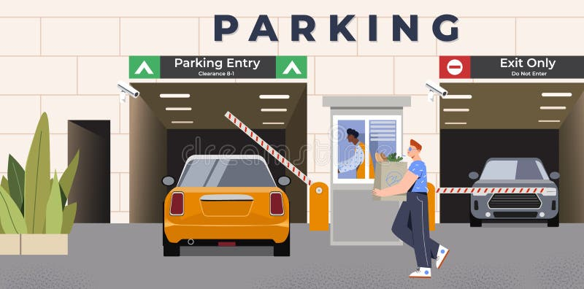
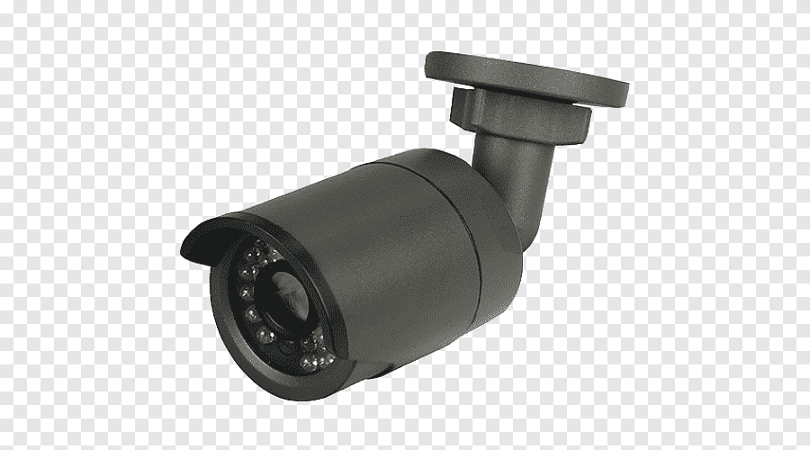

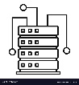
Architecture:
Camera on Exit
Web server
Camera on Entrance
Camera in parking lots


Mobile app

Remote monitoring


API communication


Deep learning based ALPR

Filled and empty slot detection
Local monitoring

Features:

Drivers:
            - Displays vacant spaces via mobile app, digital signage, or in-vehicle displays.
            - Automatic license plate recognition eliminates ticket collection and barriers.
            - Integration with access control systems for authorized parking.
            - Contactless payments with credit cards or QR codes.
            - Pre-booking and reservation of parking spaces.
            - Integrate with local parking authorities for automated ticketing.
            - Offers a convenient, safe, and stress-free parking experience for users.

For Parking Owners and Operators:
            - Tracks occupancy trends, peak usage times, and revenue generation.
            - Adjust pricing, configure settings, and monitor system performance remotely.
            - Accesses real-time data and receives alerts for potential issues.
            - Minimizes manual ticketing and enforcement through automation.
            - Automatically identifies vehicles parked illegally or exceeding their time limit.

Traffic Management Authorities:
            - Real-time parking availability data: Shares live vacancy information with navigation apps and traffic management systems.
            - Dynamic traffic routing: Optimizes traffic flow by directing drivers to areas with available parking, reducing congestion.
            - Parking demand prediction: Analyses historical data and real-time trends to predict peak parking times and areas, informing traffic management strategies.
            - Parking violation management: Integrates with enforcement systems to automate ticketing and improve compliance.

