About:

In a world where every child's safety is the chapter we can't afford to leave unguarded, Safe Heaven writes a tale of trust. Imagine a sanctuary where advanced AI surveillance harmonizes with a tap on your screen, transforming care into real-time vigilance. It's the silent sentinel in every corner, a comforting whisper to parents and guardians: "All is well." With Safe Heaven, peace of mind is not just a feeling—it's a scene in the everyday story of our children's secure future.

Architecture:
Children at school premises
Web server
Children playing in ground
Children in school vain


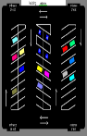
Mobile app


Local monitoring

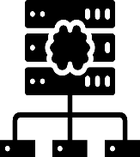

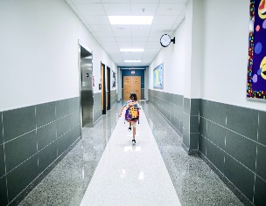

Deep learning base
Anomaly detection

Children in class room

Features:
Attendance Monitoring and Visitor Management: Automates the attendance process, identifying students and visitors through facial recognition and tracking their presence within the premises.
Emotion Detection: Analyses facial expressions and body language to identify emotional distress or abnormal behavior among children.
Location Accessibility: Monitors and controls access to different areas, ensuring children are in safe zones and restricting entry to unauthorized locations.
Bully/Harassment Detection: Identifies instances of bullying or harassment by analyzing interactions and body language, allowing for timely intervention.
Unusual Activity Tracking: Monitors and flags patterns of movement or behavior that deviate from the norm, suggesting potential safety risks or emergent situations.
Emergency Response Coordination: Integrates with local emergency services, providing rapid notification and precise location data in case of critical incidents.
Lost Child Detection and Alert: Quickly identifies and alerts authorities and administrators if a child appears to be lost or in an unauthorized area.
Real-Time Monitoring Platform: Offers a direct line for parents for real-time activity monitoring of their children.
Disability-Aware Monitoring: Adapts surveillance to ensure safety with specialized tracking and tailored alerts for children with special needs.

