About MarkIt
MarkIt is the ultimate solution for effortless MCQ paper grading. It streamlines the grading process by allowing users to simply scan their papers into PDF format and upload them to the program. Once uploaded, MarkIt takes over, swiftly processing each paper, detecting and identifying answers with precision. By comparing them against an answer key, MarkIt efficiently grades each paper, saving educators valuable time and effort

Features
Automated extraction of exam data from scanned PDFs
High-precision detection of selected answers
Flexible configuration options for various exam formats
Transformer & boxes summary (Description & location etc.)
Utilization of multiprocessing for scalable processing
Seamless integration with digital infrastructure
Reliable processing ensuring consistent grading
Comprehensive data analysis for informed decision-making
Automated exam reports generation

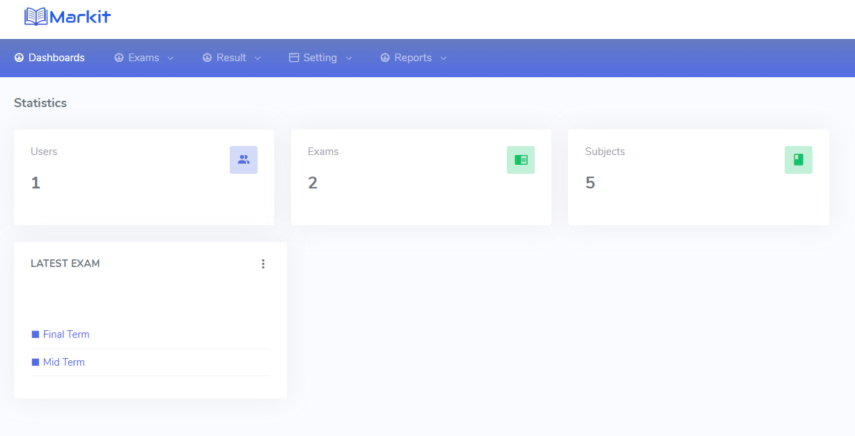

Benefits
Automation: Speeds up grading process by automating scanning and checking of exam papers
Accuracy: Ensures precise detection of answer markings, reducing human errors.
Consistency: Maintains fairness and equity in grading through standardized image processing.
Efficiency: Handles multiple exam papers concurrently, enhancing overall productivity.
Scalability: Easily scales to process large volumes of exams with minimal additional resources.
Cost-effectiveness: Long-term cost savings compared to manual grading methods.



Architecture
The architectural process begins with scanning and uploading exam papers to the server. Image processing techniques are applied to enhance paper clarity and standardization. Answer markings are then detected using machine learning models, and compared against a predefined answer key to determine correctness. Papers are graded based on this comparison, distinguishing between correct and incorrect answers. The graded papers serve as the foundation for generating comprehensive exam reports and conducting further analytical studies. This streamlined workflow ensures efficient handling of exam papers, from digitization to grading, enabling informed decision-making and assessment of educational outcomes.

